Environmental Concerns in Waterfront Development
Scottish Universities Insight Institute
The Lighthouse, Glasgow - Monday 27 October 2014

Project Partners:
University of Edinburgh, Heriot-Watt University, City of Edinburgh Council, Dundee City Council, Glasgow City Council, Architecture and Design Scotland, Planning and Architecture Scottish Government, Scottish Canals
Project funded by the Scottish Universities Insight Institute

Introduction
This Knowledge Exchange programme is bringing together practitioners, policy makers and academics involved with regeneration processes in Glasgow, Dundee and Edinburgh, which account for a substantial part of overall urban regeneration activity currently under way in Scotland, and have the potential to make a huge impact on Scotland’s future economic and social development. These three initiatives are evolving in parallel, developing their own independent approaches to city-building and to shaping the new places where people will live and work.

Through sharing experiences, the programme aims to contribute to the future development of the waterfront areas directly involved in the programme as well as other waterfront regeneration processes emerging in Scotland. In addition, it aims to guide a debate over issues surrounding economic, social and environmental aspects of regeneration activities in the country, in order to inform policy development and implementation.

The programme includes 4 workshops over 6 months, each exploring an aspect of development from each city (and including a field trip), with a final workshop providing the opportunity to draw together conclusions and identify next steps for an ongoing knowledge exchange network of policy-makers, practitioners and academics.

The first seminar in the series took place at The Lighthouse, in Glasgow on Monday 27 October 2014 where Soledad Ferrari (University of Edinburgh) and Harry Smith (Heriot Watt University) introduced the event on behalf of the Scottish Universities Insight Institute.

Michael Ward, Glasgow City Council, provided an introduction by noting ‘Glasgow is its river’ and the waterfront’s importance in the city’s story. The city is proud of recent change: formerly run down and deprived (e.g. quotes: ‘worse than East Berlin’; ‘Glasgow’s miles worse’; ‘a second class city’) there is now a more positive story being told: ‘UK’s coolest city’, ‘the new Berlin’. The strong policy context – e.g. City Development Plan and the National Economic Strategy – seeks to transform and build upon the city’s strengths by putting people and place at the heart of the story, supporting key growth sectors, and ensuring inclusion and connections.

Three main waterfront areas are: Clyde Waterfront, City Centre (e.g. new Financial District), and Clyde Gateway waterfront areas (e.g. Commonwealth Games, Athlete’s Village). New high profile regeneration has occurred through the emergence of large-scale buildings (e.g. BBC, Transport Museum, etc), but huge voids are evident in the figure ground – where objects sit in ‘splendid isolation’. The challenge for the city is to bring the river into more active use, overcome barriers, e.g. the Clydeside Expressway, and ensure better connectivity.

Glasgow City Council is seeking to develop Strategic Development Frameworks for different areas of the city (e.g. for Partick/Govan – make connections) and along the entire Clyde corridor. The Canals, which closed in 1960s, are now also a catalyst for positive change and visitor destinations, e.g. focus on leisure: paddle centre.

Richard Millar, Scottish Canals, (Forth & Clyde, Crinan, Caledonian, Union and (part) Monkland canals) described how the 70 miles of waterway provide 140 miles of waterfront opportunities. The canals originated 1768-1820s from enterprise born of the Scottish enlightenment, moving freight and delivering jobs. In the 1850s canals were challenged by the railways and by the 1940/50s had fallen into decline and disrepair; the eventual motorways led to the abandonment of the canals in the 1960s. By 1990s there was belief that they could come back to life to support communities. The Millenium funded Falkirk Wheel and the more recent Kelpies/Helix projects are visitor attractions providing local employment and supporting the local economy.

Canal regeneration projects help to bring uplift in adjacent land and property values; work with local social enterprise to transform existing run down assets (e.g. heritage buildings); provide linear parks; act as a catalyst to bring new life to areas; benchmark quality for new development; work with assets to create identity. River / motorway / canal have acted as boundaries/barriers to disconnect communities; efforts are being made to re-connect (e.g. ‘metal petal’ motorway underpass). At Speirs Wharf working with cultural organisations (e.g. Scottish Opera) to transform and change perceptions of the area: The Whisky Bond, The Glue Factory, sculpture studios, creative hubs.

Scottish Canals are exploring new ways of commercialising the water – residential moorings provide new ways of living and are in demand; areas for sports activities; ‘go ape’ over the water; paddle centre; trim trail; white water sports training – all with intention of involving local communities; in association with distillery; as hold and attenuation areas for run-off from new development; health benefits; arts based projects. Canals contribute £55m GVA; investments lever considerable returns and wide benefits.

A field trip study tour took participants to visit Port Dundas (from the Pinkston Water Sports centre to The Whiskey Bond) and Govan.

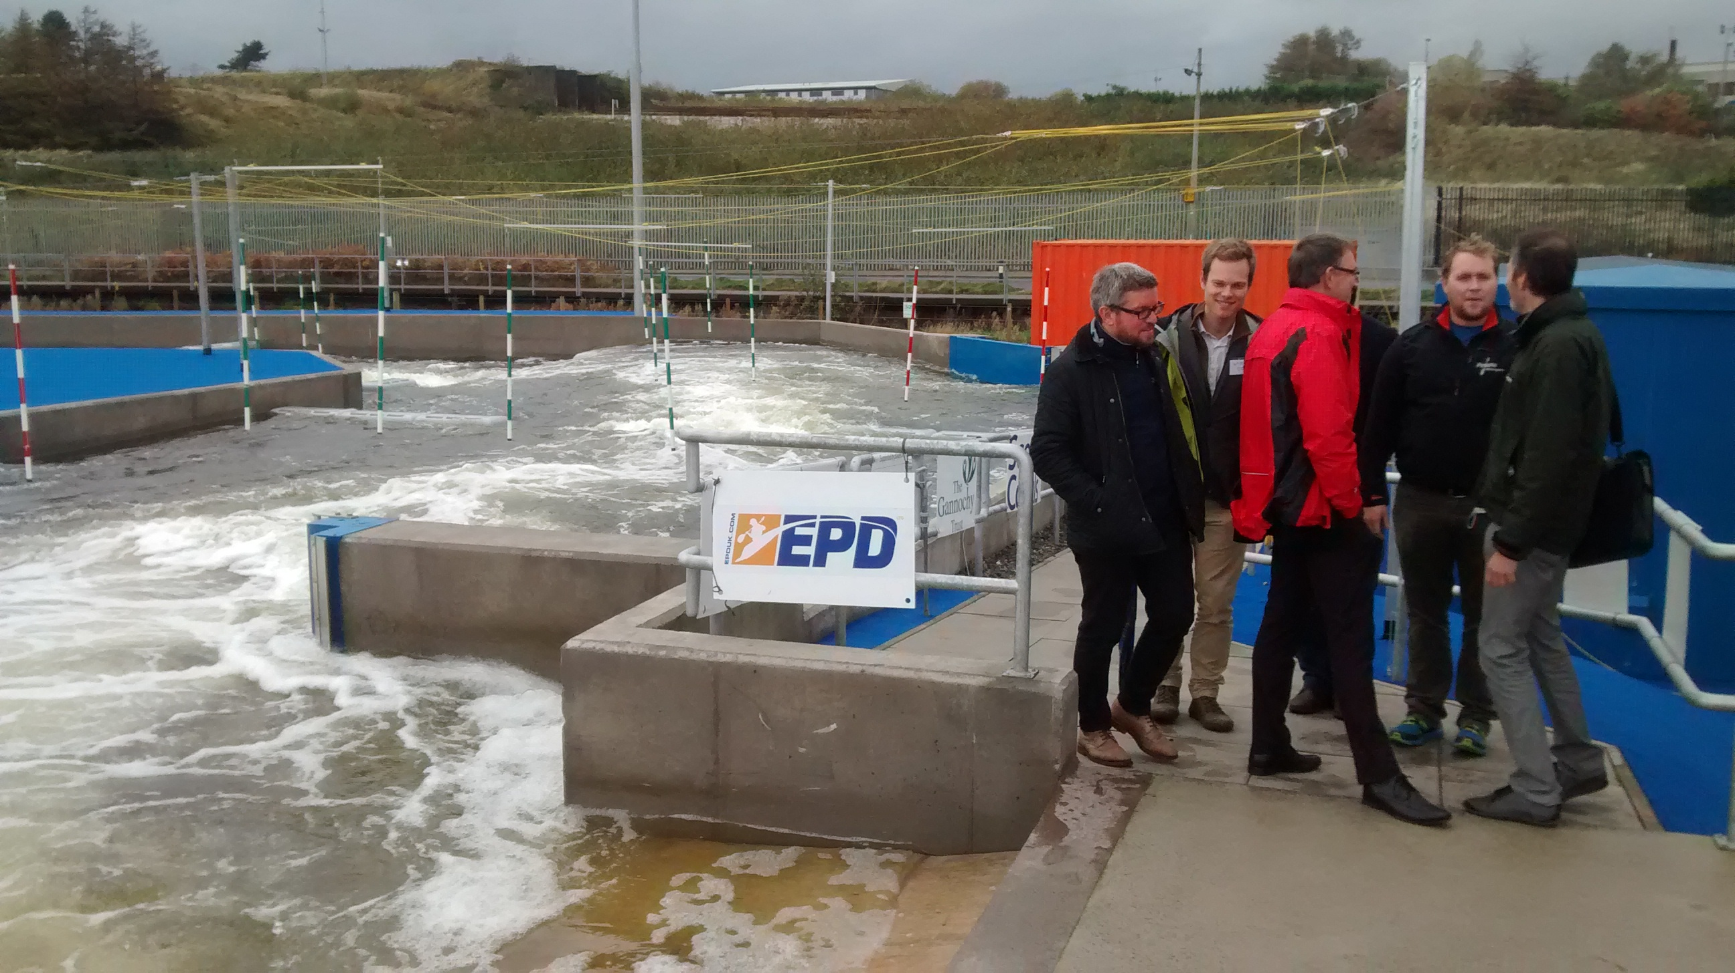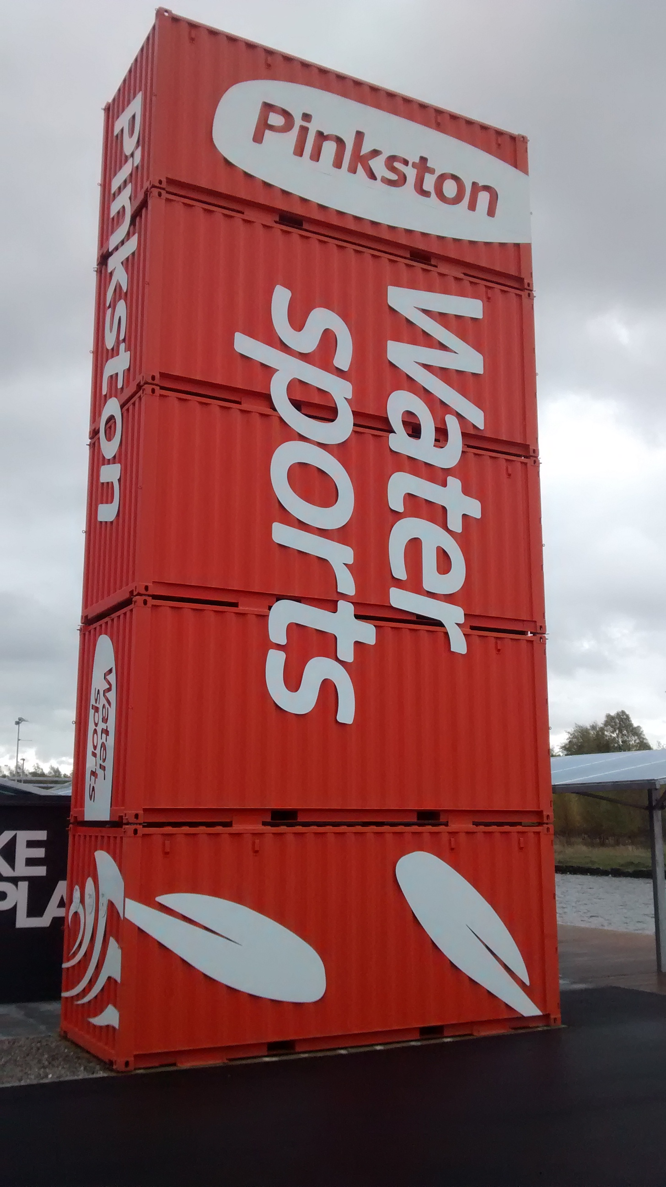

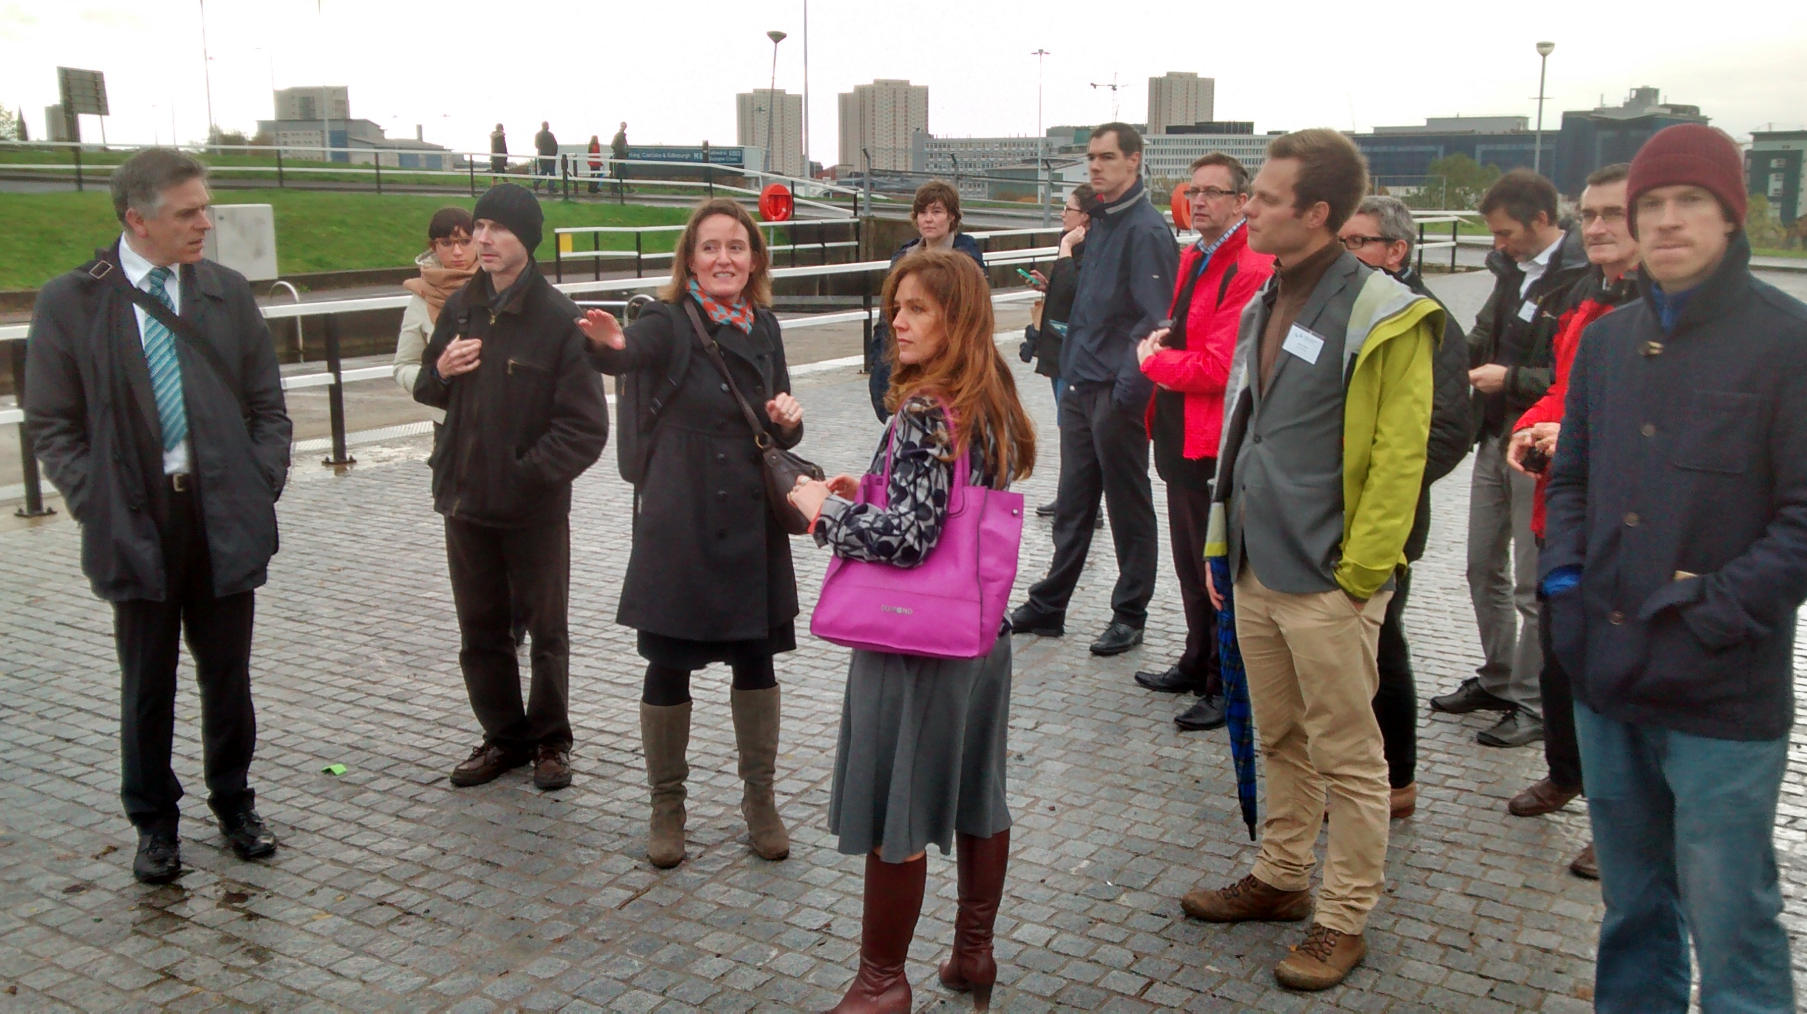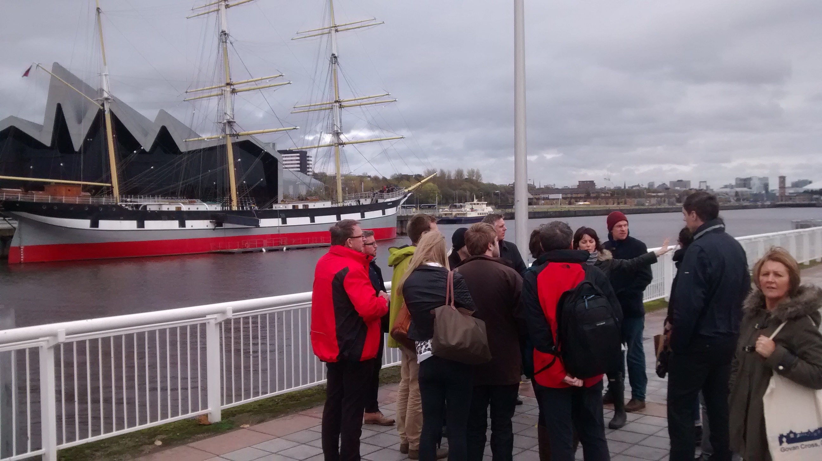

Daniel Skog, City of Malmo, described how Malmo’s main employer, the shipyard, had gone from prosperous low unemployment in the 1960s to decline in the 1970/80s; by 1986 the shipyard had closed. Major rescue plans (e.g. new SAAB car production plant) were unsuccessful, and people lost hope. The city bought the entire western harbour and invested in the land which was then sold on in small packages to developers to ensure diversity. Although the harbour area feels ‘far away’, it is close to the centre of a compact city, which made a decision not to extend beyond the outer ring road. New housing for 100k people was to be provided on old vacant industrial land. A new university of 25k students has a significant impact in a city of 3.5k inhabitants; helping to attract and retain a younger population (50% < 35).

The design by an architect employed by the city (Klas Tham) was inspired by medieval designs that offer unexpected encounters. Leadership was provided by the Mayor (a former architect). A new landmark building – the Turning Torso – is a signal / recognition point (replacing the former crane) and an exclamation mark signifying the debate about the future of the area. Six storey external perimeter blocks shelter the interior of the site from the exposed winds and ensure a good micro-climate; a European housing expo in 2001 attracted a range of architects to ensure diversity. 100% renewable energy is produced on site and stored in underground basins integrated into the design.

The city co-operates with developers in a positive way to create common development goals (what should we achieve?... how parking should be handled?...) and oblige developers to co-operate with each other: i.e. install common waste handling systems (food waste produces bio-gas to power cars, taxis, buses); district heating solutions; common study tours to get the same kind of background information; think about energy and consumption; green space factors; bio-diversity; above ground rainwater handling; easy and attractive mobility; operating public transport from the beginning. Developers put savings from not having to provide car parking into supporting a car club (by day for companies; by evening for residents) to reduce car ownership and provide free membership to new residents. The City contacts new occupiers to provide travel maps and timetables to help establish new behaviours.

The ocean wall is a popular spot for Malmo people; a place where people from all parts of the city come to mix and enjoy. Cafes and restaurants have opened; outside concerts take place. Things that are unexpected have happened: people started to swim in the sea; instead of stopping this, the city has facilitated this by employing lifeguards and providing steps and ladders down to the water level. The area has become a destination. A further decked area had to be provided. Old buildings have been re-used.

Originally the shipyard employed 7k people; today 10k people are employed in a variety of different companies. People engage in civic processes and sit on a community panel to guide budget investments. There are benefits from the bridge link to Copenhagen where 40k people commute daily. Co-operative and ‘unholy’ alliances have been formed. Future phases (including in private ownership) are being informed by the first successful development phase.

Justin Abbott, Arup, gave a presentation on water sensitive urban design and noted there are significant global drivers for thinking about water. He spoke about ‘water management as a source of civic pride...’; a starting point for bringing together multiple interests; where lots of small interventions can offer better alternatives to one heavily engineered solution, and adaptive interventions ensure a ‘no regrets’ approach which allows for future variation. Water influences urban form and there is a need to reconnect people with water.

When investments are made there is a need to achieve other benefits through overcoming silo thinking; a business case for delivery may fracture across various parties. Understanding benefits can be through monetising: all bodies have an interest in water – how can they all be joined up and linked? E.g. energy use, food production, connections, water management, etc. All can be combined to bring together different outcomes. Current ways of working are not sustainable. Various international case studies showed how it is possible to see projects in terms of wider catchment areas with the potential to deliver more than just the project.

A subsequent group discussion reflected on lessons from the site visits and presentations to identify factors contributing to environmentally sustainable waterfront regeneration in Scotland under three areas: a] resources, b] rules and organisations and c] ideas and mindsets. Each of these areas was discussed by a separate break-out group and then reported back. Summaries of the break-out group discussions are as follows:

Theme a: Resources

Question 1: What resources are needed to develop an environmentally sustainable waterfront regeneration and development?

- Vision (idea) and leadership as resource
This vision should show agreement across all scales and levels of partners and organisations involved.
Linked to this is the need to achieve connected thinking – economic development and regeneration should both be interlinked and part of the shared vision
Ecosystems analysis

- Land ownership – allows for the proposal of much stronger rules to guide the development.
Access to land would also help to initiate the development – kick-start development – but having a vision is essential, otherwise the risk is for a fragmented development, lacking connectivity.

- Central Government funding – might be available for servicing, de-risking land, remediate land, attend problems in disadvantaged areas. Access to this central funding may enable development, perhaps may contribute to release or remidiate land.

- De-regulation of the public transport system – can also be a resource as these areas are usually disconnected to the city and new demands will emerge.

- People – are an essential resource for the success of the development. A long-term commitment from people is key. They must be consulted, they must get involved from the initial stages and they should take ownership of the development.

- Masterplan and design coding - Good urban design – This could be developed and led by the local authority, perhaps using design charettes. Should be developed in association with land owners and developers.
This masterplan must be deliverable.
The masterplan should be developed considering broader conditions for investment and broader context for regulation – the added value of these should be clearly explained.
For example – in Malmo, the boundary that was created around the city to stop the expansion of the urban fabric was a key element contributing and preserving the Western Harbour masterplan.

- Strong regulatory framework, which considers a variety of aspects in the development. For example in Malmo regulations are very strong and important – these include parking, cycling routes, height of buildings, density, etc.
Land control and regulation are essential for raising the standard of the development.

- Creating a sustainable community. Not only housing but also access to Jobs and other activities in the area – In Malmo for example, there are small consultancy, IT companies, in addition the University employs a significant amount of people in the area.

Question 2: What resources do waterfronts already have that may contribute to this?

- Scale - Waterfronts usually offer large areas of ‘cheap’ land. Value for money.

- Water – People are drawn to water. People’s psychological connection to water.

- Wind and water – have also the capacity to be used for power generation.

- Use of water as activity. Water as common recreational resource. However this may also require planning. Example – Clyde, there are some rowing clubs, which could be included in the development. Water can also be an environmentally friendly mean for transport.

- Connectivity of waterfront areas – could be a resource. Normally as these were previously industrial areas tend to be well connected.

- Centrality – waterfront tend to be very central to the city.
However they may be disjointed with the city and development tends to need to joint the city to the water better.

- Cultural heritage and history. Waterfronts tend to provide cultural identity for the city. They have distinctive character within the city.

- The type of life the development in waterfront areas offer can be unique for the city. In the case of Malmo, Western Harbour offers the most ‘modern’ lifestyle in the city.

- Opportunities for innovation that these areas may offer with regards to sustainability, energy efficiency, lifestyle, can contribute to gaining funding. Waterfronts can be an opportunity for implementing new ideas and this innovative vision can attract funding such as from international organisations as the EU.

Problems

However financial resources are low at local authorities and government organisations. The Canals in Scotland have the advantage of being led by an organization aimed to stimulate development – Scottish Canals.

Management of public spaces is essential. Regulations need to be drawn up to include the ‘green space factor’. Quality of green space is fundamental.

With regards to public spaces - Scandinavia may have better management structures for housing – in the case of apartments. In Malmo de development aimed to attract older, perhaps retired people, who used to move out of the city centre.

Summary of key points from Theme 1 discussion:
Vision – leadership → Masterplan!
Land management / ownership
De-risking
People – Community led regeneration → ownership = sustainability
Charettes
Masterplan → deliverable / flexible
Regulation of hinterlands
Not just housing, jobs
Resources
Water! → psychological
Scale, VFM
Location – transport links
Connectivity – historical
Recreational resources → a focus for integration and cohesion
Water as a drainage resource → canals etc.
Water as a transport route
Opportunity for innovation → access to EU funds

Theme b: Rules and organisations

Question 1: What organisational arrangements and inputs can foster environmentally sustainable waterfront regeneration and development?

Question 2: What rules/regulations may contribute to an environmentally sustainable waterfront?

Both questions were addressed together in the discussion, using Govan and Glasgow Harbour to large extent as focal points, drawing on what had been seen during the study visits in the morning.

In the regeneration of Govan they looked at the types of organisations and saw that there was a relationship between the type of organisation and the type of development. Glasgow Harbour has one developer, with a site that had no residents or buildings. The approach was purely market-driven. This led to a huge amount of development very quickly until the financial crisis hit, and now it still has land to develop.

On the opposite of the Clyde, in Govan, there is a large population, deprivation and the social and economic legacy of a large shipyard which disappeared. The Central Govan Area Action Plan is strongly driven by the public and community sectors, linking the local authority with community-driven initiatives. Housing Associations (HAs) are very involved. The local project team is based in the area. The Steering Group includes HAs and local tenant associations. It is very democratic, and the local authority can be challenged. Permanent members include bodies with wider responsibilities such as Strathclyde Transport.

These two approaches have delivered different products on the ground. Glasgow Harbour is driven by how much physical development can be put on the land. In Govan there is a wide range of demands: social, economic, heritage, poverty. Neither at this stage has delivered the best result so far. The Govan model is more democratic and diverse, while Glasgow Harbour is quire sterile.

Govan provides an example of opportunity based on drawing on the strengths of different partners. There isn’t an off-the-shelf model for environmentally sustainable regeneration of Govan, and maybe not for Scotland either. In physical terms, maybe small towns would provide a model.

Previously Glasgow City Council produced a development brief and gave control over to the developer. But how to you maintain control to achieve goals? When do you deliver parts of a vision? There is a tension in the phasing of the process.

In Govan there is involvement of third sector organisations, including examples such as GalGael, which promotes traditional boat-building, and is premised on the idea of bringing back the working river. This stretch of the river Clyde is a harbour originally owned by the Clyde Port Authority, which was then sold to The Peel Group. This is a property developer, which is more interested in property development than in the water as such. So the land around the Clyde waterfront that is owned by The Peel Group has become a property asset.

In Edinburgh, Waterfront Edinburgh Limited was the developer that went the furthest in developing quality public space.

In Dundee the physical development on the waterfront is small grain, with the Council owning the land. There are issues to be addressed, such as the developers not liking the use of party walls and considering separating each city block into smaller physically separate built units.

Larger scale requires a concerted strategic approach. For example around the Riverside Museum on north bank of the Clyde there is a large area of undeveloped land with a masterplan which forms the basis of an outline planning consent. Areas such as this require small scale development to make the environment on the Clyde less hostile (microclimate etc) – achieving this requires planning policy and urban design. The scale of development on land opposite the Museum could become a pilot. Common themes of waterfronts in Scotland are deindustrialisation and sites that are cut off by roads (e.g. in Glasgow and Dundee).

Though the discussion was about organisations and rules, it inevitably overlapped with the key themes of the other two discussion groups:
- Resources are a big issue: capital resources and human resources (massively reduced in the local authority). There needs to be a well-resourced organisation that deals with the Clyde, with different skill sets (environment, water, urban design) including more traditional disciplines, and with a much greater concern for public space.
- A cultural shift is needed. For example, linking to rules and regulations, regional planning has a role. Following the example of strict boundaries to development beyond the ring road in Malmo, a stricter approach to development beyond the urban area would aid waterfront regeneration in Scotland. This would require Scottish Government input to coordinate and implement strict masterplans. Also, in Glasgow there is a need to think of the waterfront as part of Glasgow rather than as a separate development (e.g. Clyde Waterfront is like an island of development). Waterfront regeneration needs to be as much about what is beyond the edge as it is about the edge.

Summary – key discussion/points above reported back to other workshop participants:

Organisational arrangements
Govan/Glasgow Harbour comparison:
- Govan: democratic, different views, concern about place.
- Glasgow Harbour: if the money is there it is very effective; priority is profit; requires strong policy.
Range of skills / urban design.
Organisation for Clyde.

Rules/regulations
Different scales: from region (morphology of regeneration) to small scale (masterplan, boat building)
Much greater concern about place / public space
Relate to context – connections

Theme c: Ideas and mindsets

Question 1: What makes a waterfront environmentally sustainable?
Good clean water quality; Flora and fauna; diverse habitat
Humans are drawn to water – take advantage of that; link environmental/social/economic sustainability
Good connections / ease of access – transport infrastructure has been a barrier hindering access – not enough research about how waterfronts are cut off as legacy of transport - e.g. waterfront museum is not easy to get to – you can build anything you like, but no good if you can’t get to it!
Water is a place attraction; but can also be a divide – e.g. Govan/Partick
Water is the starting point for bringing things together (e.g. Arup presentation) – water as engaging point in discussion – different interests: everyone benefits; but whose responsibility is it to deliver (e.g. bridge)? Need to work together – policy is good, but need to come together
Lead by actively acquiring land to deliver – could be stronger on land assembly i.e. Europe
Mindsets different – work at scale to achieve things – possible scale to implement CHP / waste extraction systems
Leadership & Vision – lead; take a risk; invest in the future of the city – this will benefit the city economy (value in monetary terms?)
Get the community engaged and supportive
Councils stewards of the public purse –risk averse; do things differently – takes time to filter through
Urgency – do things differently: new economy; global challenges / climate change; deliver broader benefits – links to SGov agenda and Health & Wellbeing
Identify benefits that flow from positive change – estimate forecast in rising benefit – value intangibles – work off evidence, data, research
Built environment not good at identifying return on investment; need to forecast and evidence base
Dundee working with Green Network, Green & Blue assets, and H+W /NHS agenda
Change mindsets: recognise benefits that arise – people who don’t traditionally see themselves as assisting indirect agendas to deliver outcomes need to be made aware

Question 2: What attitudes are [not!] in place to contribute to an environmentally sustainable waterfront?
Understanding of how this assists mutual benefits
Divert funds from treatment to preventative spend
Leadership – people saying the right things – need to follow through with joined up action
We have too many plans and strategies – why? Only need one – then everyone realises their role in delivering. ‘Our plan is your plan’ – avoid repetition; bring together as corporate plan
New language in engaging with communities – not Urban Design ‘legibility, etc...’ – instead: ‘how does it make you feel?’ Better engagement process
Corporate approach – we spend time working with communities to gain faith and build up trust, then another part of the Council comes along and drives through a bad decision (e.g. Fastlink/ transport) which undermines all the good work
Need a change in silo mentality - Need wider appreciation of how everyone delivers outcomes – not under technical, professional silos but under e.g. wider H+W
Vision – here’s your role to help deliver this
Participatory budget – community reps help set budget and access £s – devolved power
Glasgow’s Community Planning has gone opposite way – now centralised – hard to access £/decision
Need to be aware of what people want (e.g. Malmo people wanted to swim – council worked out how to help support that – instead in G would say: don’t do it, and put up barriers!) – mis-match of perception and reality – change mindsets: over regulated environments/standards approach
1965 Roads Standards – over designed pedestrian crossing – problem of silo thinking

Summary – reflecting on discussion/ points above, what is one standout point from each person:

What makes a waterfront environmentally sustainable?
- Activity
- Bio-diversity
- Energy efficiency (e.g Malmo initiatives)
- Effective transport capacity – barrier v connection
- Water as a catalyst for making things happen

What attitudes are [not!] in place to contribute to an environmentally sustainable waterfront?
- Attitudes to risk - e.g. funding
- Attitudes to risk – e.g. access to water
- Leadership – realise scale of opportunity; land assembly
- Changing silo culture
- Holistic / corporate approach to delivering outcomes (too compartmentalised)

The next seminar will take place in Dundee on Monday 1 December. For more information refer to http://www.scottishinsight.ac.uk/Programmes/Programmes20142015/WaterfrontRegeneration.aspx or contact Dr Soledad Garcia Ferrari (University of Edinburgh) or Dr Harry Smith (Heriot Watt University).

